Regex Tasks:-

1. Get all files in your windows directory that have a two Digit Number as part of the name:-

=>I tried on D Directory with the below command

get-childitem D:\ -Recurse | select-string -pattern "^[0-9]{2}$"

2)In the Windows Update log ,you want to display only the lines where the agent began installing files

=> Get-Content -path D:\WindowsUpdate.log|Select-String "(.+IsInstalled)"

3)write a Regex to validate the IPV4 address?

=> "172.23.4.17899" -match "^(([0-9]|[1-9][0-9]|1[0-9]{2}|2[0-4][0-9]|25[0-5])\.){3}([0-9]|[1-9][0-9]|1[0-9]{2}|2[0-4][0-9]|25[0-5])$"

4) write a Regex to validate the email id?

=> "sarikagaonkar678890000ghghg@hotmail8com" -match "^[\w-\.]+@([\w-]+\.)+[\w-]{2,4}$"

5) write a Regex to validate the sid of AD user?

=> "S-1-5-21-1742464477-6312997457-3622578892-127" -match "/^S-1-[0-59]-\d{2}-\d{10}-\d{10}-\d{8}-[1-9]\d{3}/"

6) Create a script which can delete the files only \*.log from the

“C:\demo\files” location

* I copied the log file at D:\demo location

Get-ChildItem \*.log -Path D:\demo\ -Recurse|Remove-Item -force

6) I will provide first number and second number . need an output as even or odd number

=>

[int]$k =Read-Host "Enter your first Number"

[int]$j = Read-Host "Enter second number"

for($i=$k ;$i -le $j ; $i++)

{

if($i % 2 -eq 0 )

{

Write-Host "$i is even"

}

else

{

write-host "$i is odd"

}

}

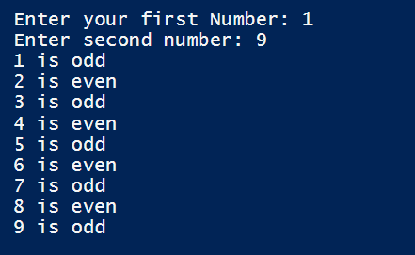

8) I need an output as below for each service you have

=> I tried with BITS first as below:-

$srvName = "bits"

$servicePrior = Get-Service $srvName

$srvName + " full form is " + $servicePrior.DisplayName

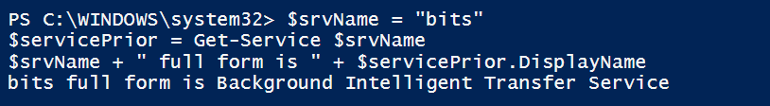

Then tried with all services as below :-

Get-Service | select name | Export-Csv D:\demo\allservicesname.csv

$bits= Get-Content -Path D:\demo\allservicesname.csv

foreach($bit in $bits)

{

$srvName = $bit

$servicePrior = Get-Service $srvName.ToString()

$srvName + " full form is " + $servicePrior.DisplayName

}

Output:-

